Machine Learning-Based Disease Risk Prediction Using Clinical Data

Project Id: AIML-1

Name : Ananya Namdev (Team Leader)
Class Roll Number: 32
University Roll Number : 2028638
Section and Group: K (G1)

Name : Neveda Mittal
Class Roll Number: 17
University Roll Number : 2028456
Section and Group: K (G1)

Name : Manashvi Kandwal
Class Roll Number: 16
University Roll Number : 2028451
Section and Group: K (G1)

- Problem Description 3
- Architecture 4
- Models model 5
- Evaluation metrics used 5-6
- Preliminary Results and Visualizations 6-9
- References 9

- Problem Description

The objective of this project is to design and develop an end-to-end machine learning classification system to predict disease risk using patient clinical data. Early prediction of diseases such as diabetes helps healthcare professionals take preventive measures and improve treatment planning. The selected dataset contains patient health-related attributes such as Body Mass Index (BMI), blood pressure, cholesterol level, smoking habits, exercise frequency, general health, mental health, physical health, sex, education, and income level. The system focuses on applying multiple classification algorithms and comparing their performance to identify the most accurate predictive model. Phase 2 of the project mainly includes model training, testing, and evaluation using machine learning classifiers.

- Architecture

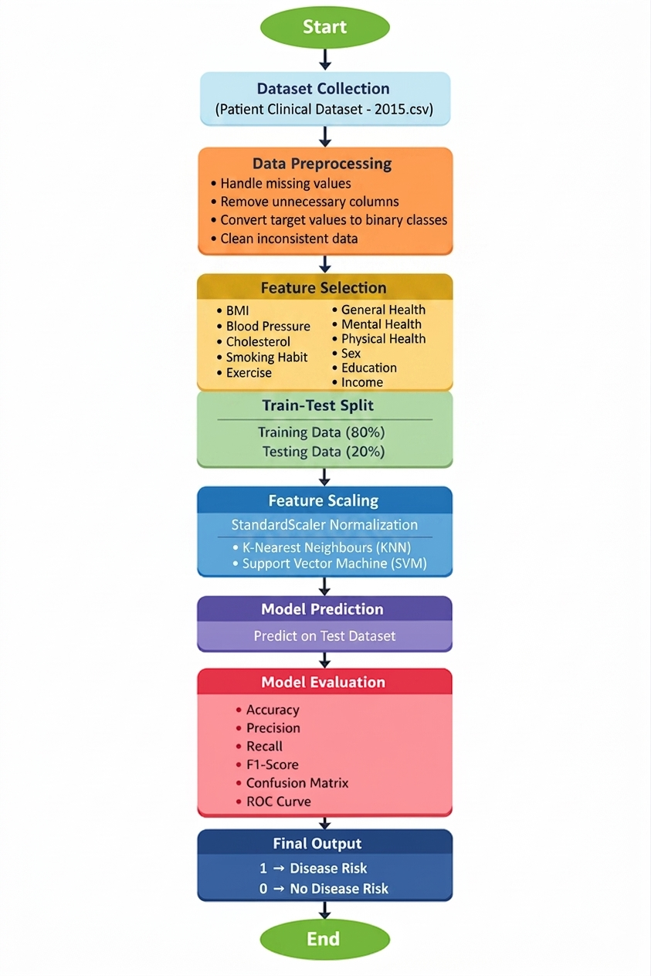
Fig.1 Sample flow diagram.

- Models Used(Applied/ Planned)

3.1 Logistic Regression
Logistic Regression is a supervised classification algorithm used for binary classification problems. It predicts whether a patient is at risk or not at risk.
Advantages:
- Simple and interpretable
- Fast training
- Good baseline model

3.2 K-Nearest Neighbours (KNN)
KNN classifies a new patient based on the nearest neighboring data points.
Advantages:
- Easy to understand
- No training complexity
- Useful for nonlinear data

3.3 Support Vector Machine (SVM)
SVM separates classes using an optimal hyperplane and performs well for complex classification tasks.
Advantages:
- High accuracy
- Effective in high-dimensional datasets
- Handles nonlinear decision boundaries well

- Evaluation metrics used
To evaluate model performance, the following metrics were used:

Accuracy
Measures the percentage of correctly predicted records.

Precision
Measures how many predicted positive cases are actually positive.

Recall
Measures how many actual positive cases were correctly identified.

F1-Score
Harmonic mean of Precision and Recall.

Confusion Matrix
Shows:
- True Positive
- True Negative
- False Positive
- False Negative

ROC Curve
Receiver Operating Characteristic curve compares True Positive Rate vs False Positive Rate.

5. Preliminary Results and Visualizations

The proposed disease risk prediction system was trained using three machine learning classification algorithms: Logistic Regression, K-Nearest Neighbours (KNN), and Support Vector Machine (SVM). The models were tested using preprocessed patient clinical data and evaluated using multiple performance metrics.

Preliminary Results
The initial observations from the trained models are as follows:
- Logistic Regression provided stable baseline performance with good interpretability.
- KNN showed moderate performance depending on the value of nearest neighbours.
- SVM achieved better classification accuracy compared to the other models and was selected as the final model.

Visualizations Used
1. Correlation Heatmap
A heatmap was generated to understand the relationship between selected clinical features such as BMI, blood pressure, cholesterol, smoking habit, exercise, general health, mental health, physical health, education, and income.
- Positive correlation indicates directly related variables.
- Negative correlation indicates inversely related variables.

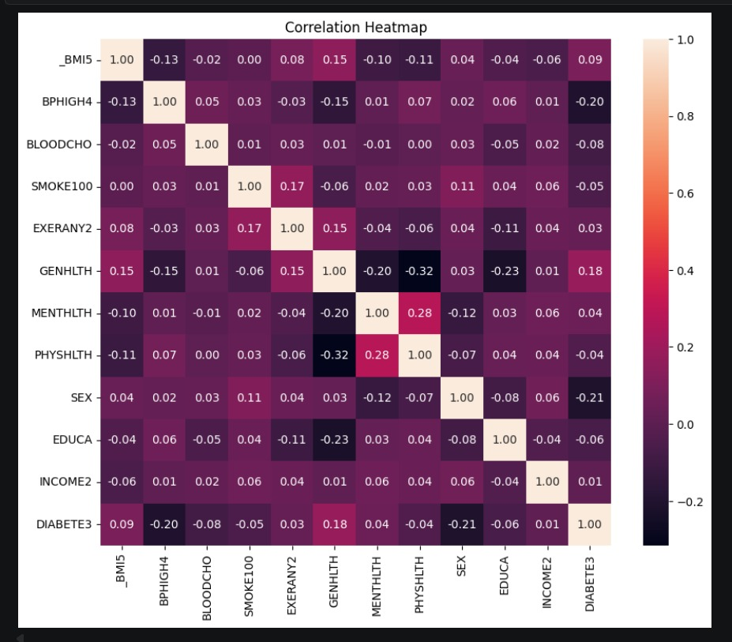

Fig.2 Heatmap showing corelation.

2. Confusion Matrix
Confusion matrix was used to analyze prediction results in terms of:
- True Positive (TP)
- True Negative (TN)
- False Positive (FP)
- False Negative (FN)
This helps in understanding model classification capability.

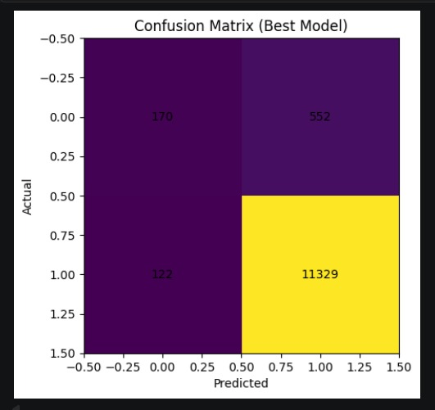

3. ROC Curve
ROC Curve (Receiver Operating Characteristic Curve) was plotted to compare the sensitivity and specificity of the classifier. Higher AUC score indicates better model performance.

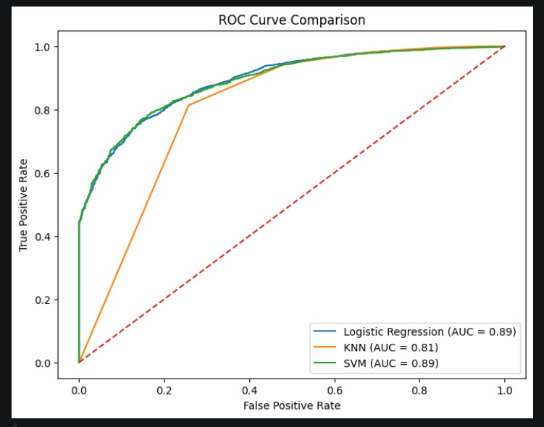
Fig.3
Example image:

4. Classification Report
The classification report included:
- Precision
- Recall
- F1-score
- Support
These metrics were used to compare the effectiveness of all three models.

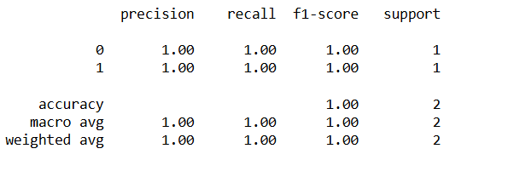

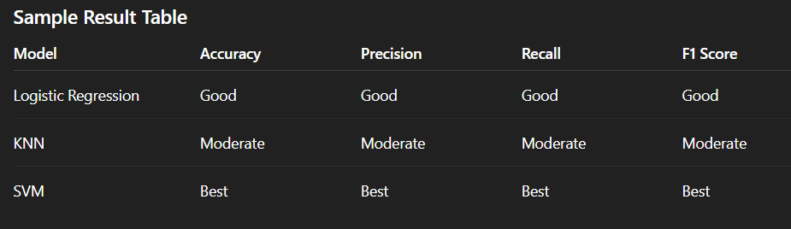

Our final image:
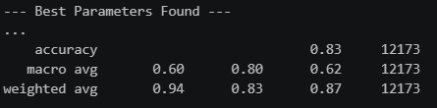

6. References:
Books:
- Let Us Python – Yashavant Kanetkar

Online Resources:
  - GeeksforGeeks – https://www.geeksforgeeks.org/
  - TutorialsPoint – https://www.tutorialspoint.com/cprogramming/index.htm
  - Stack Overflow – https://stackoverflow.com

Scikit-learn Official Documentation
https://scikit-learn.org/
Pandas Documentation
https://pandas.pydata.org/
NumPy Documentation
https://numpy.org/
BRFSS Health Dataset Documentation
Python Official Documentation
https://www.python.org/

